## **Strive for Consistency: -**

GeekforSeeks sets an excellent example by using the same font throughout its webpage. This uniformity enhances user experience, making navigation and content consumption smoother. It fosters a sense of unity and familiarity, while also strengthening the site's brand identity. In essence, sticking to one font makes GeekforSeeks' design user-friendly and memorable.

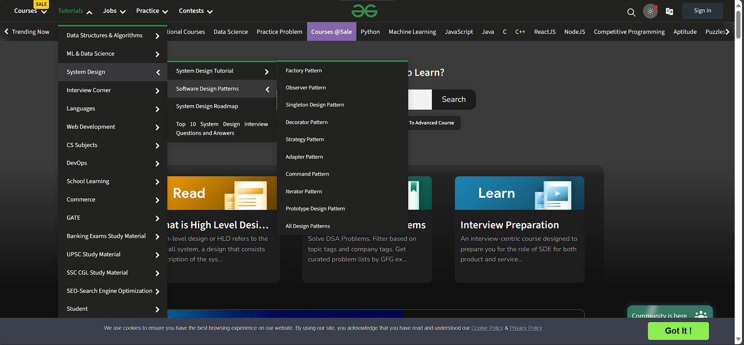

Shortcuts:

As shown in the below picture there is quik shortcut tabs to navigate the various sections of the website by just clicking one click

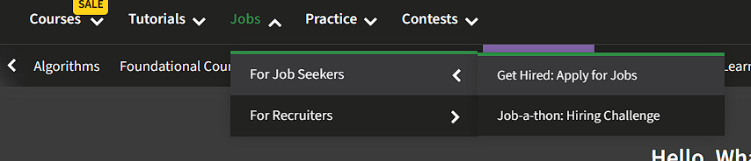

Informative Feedback: -